Name : Sakthi Manoj R Reg No : 192324236
PROGRAM 4
Create Arrays from Vectors with Dimension Names and Print Specific Elements
Aim:
To create arrays from vectors with dimension names and print specific elements.
Procedure:
Step 1: Open RStudio or R console on your system.
Step 2: Create a sequence of numbers and store it in a variable.
Step 3: Use the array function to arrange these numbers into multiple dimensions by specifying the number of rows, columns, and tables.
Step 4: Store the created array in a variable.
Step 5: Display the entire array to view how the elements are arranged in each layer.
Step 6: Access a specific element from the array using its row, column, and table position.
Step 7: Print the selected element to verify correct indexing within the array.
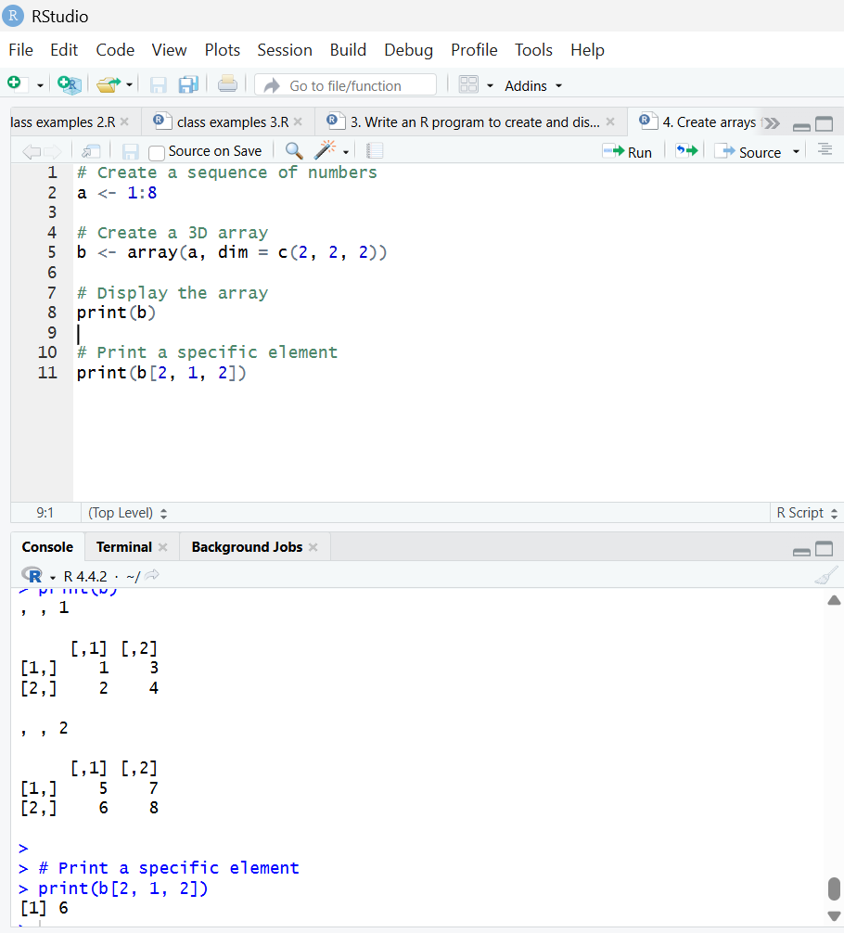
Result:
Hence the output is verified successfully.

